}

Guía1. Definición Proyecto APT
Asignatura Capstone

- PARTE I
1. Antecedentes Personales
A continuación, se presenta una tabla en la que debes completar la información solicitada.

Nombre estudiante | Jurian Soto  Pamela Romero  Darko Rivas
Rut | 19.023.656-0  19.442.181-8  19.417.706-2
Carrera | Computer Engineering
Sede | Puente Alto

2. Descripción Proyecto APT
En la descripción debes señalar brevemente el nombre de tu proyecto APT y las competencias del perfil de egreso que vas a poner en práctica. Si en tu carrera están definidas las áreas de desempeño, también menciona a qué áreas de desempeño está vinculado el proyecto.

Nombre del proyecto | MyBalance
Área (s) de desempeño(s) | Front-End Development, Back-End Development, Databases, Software Quality, and Project Management
Competencias | Design and develop innovative, high-quality software solutions by applying best practices and considering the software development life cycle.  Design solutions that address information requirements through the use of databases.  Evaluate and manage IT projects using management methodologies and tools, considering both traditional and agile environments.  Design software solutions considering standards, security, quality, and sustainability.  Develop software solutions for mobile platforms and devices using appropriate frameworks, tools, and programming languages.

3. Fundamentación Proyecto APT
A continuación, se presentan distintos campos que debes completar con la información solicitada. Esta sección busca que describas en detalle tu proyecto y justifiques su relevancia y pertinencia.

Relevancia del proyecto APT | The MyBalance project arises from the need for a tool that helps people organize different aspects related to their habits and daily lives. Currently, this type of information is often managed through separate applications, resulting in fragmented data that makes it difficult to maintain consistent tracking and obtain an overall view of the progress achieved.  This issue mainly affects people who want to better organize their activities and track goals related to their well-being and daily lives. MyBalance aims to address this need through a modular mobile application that allows users to record information, set goals, and view indicators related to their progress.  The project is relevant to the field of Computer Engineering, as it requires the application of knowledge related to requirements analysis, software design and development, databases, systems integration, security, testing, and project management. Its contribution is to develop an accessible technological solution that centralizes information and facilitates its monitoring through dashboards, reports, indicators, and tools that support personal organization.
Descripción del Proyecto APT | MyBalance involves the design and development of a mobile application focused on personal organization and the tracking of different aspects of daily life.  The solution will be structured into modules, initially including Food and Hydration, Finances, and Smoking Cessation. These modules will allow users to record information, set goals, review historical data, and visualize their progress.  The application will also include a general dashboard, notifications and reminders, along with a gamification system based on points and rewards. The points earned may be used to unlock customization elements within the application, including features associated with a virtual pet.  The solution will consist of a main mobile application, a backend, a database, and administrative components that will work together in an integrated manner to support the functionalities defined for the project.
Pertinencia del proyecto con el perfil de egreso | The MyBalance project is directly related to the graduate profile of the Computer Engineering program, as it requires the integration of different competencies developed throughout the degree in order to design and implement a complete software solution.  During the development of the project, it will be necessary to apply knowledge related to requirements analysis and elicitation, software solution design, mobile application development, Back-End programming, database modeling and management, integration through API services, security, quality assurance, testing, and project management.  These competencies will be necessary to implement a solution composed of a mobile application developed using React Native and JavaScript, a backend developed in Python, a database, a layered architecture, and communication through a REST API. In addition, the project considers authentication and authorization mechanisms, system administration, dashboards, indicators, reports, and integration with external services.
Relación con los intereses profesionales | The MyBalance project is aligned with the professional interests of the team, as it brings together different areas of Computer Engineering, such as software development, programming, databases, information analysis, software quality, and project management.  The development of the solution will allow the team to apply knowledge acquired throughout the degree in a comprehensive project that includes a mobile application, a backend, a database, integration services, administrative functionalities, dashboards, and indicators. This allows each team member to contribute from different areas while strengthening competencies that will be relevant to their future professional performance.  The development of MyBalance represents an opportunity to work collaboratively on a project that closely resembles a real-world software development scenario, involving activities such as analysis, design, programming, integration, testing, and management. In this way, the project contributes to the professional development of the team by allowing them to apply both technical and organizational knowledge to a concrete
Factibilidad de desarrollo del Proyecto APT | The MyBalance project is considered feasible to develop within the academic period, as it has a defined schedule from August 19 to December 9, 2026, organized into sprints that allow the team to progressively address the analysis, design, development, testing, and closure stages.  In addition, the Work Breakdown Structure (WBS) includes a distribution of hours and responsibilities by role, while the technologies defined for the project, such as React Native, JavaScript, Python, and a REST API, allow the solution to be developed mainly using free or open-source tools.  Possible difficulties include delays, changes in requirements, or integration issues. These can be addressed through progress monitoring, change control, progressive testing, and task redistribution when necessary.

- PARTE II
4. Objetivos
En este apartado debes definir objetivos generales y específicos del Proyecto APT. Es importante aclarar que los objetivos se deben plantear en forma clara, concisa y sin dar mayores explicaciones, es decir, deben entenderse por sí solos. Se sugiere redactarlos utilizando un verbo en infinitivo, pues ello obliga a precisar acciones concretas.

Objetivo general | Design and develop MyBalance, a mobile solution focused on personal organization and habit tracking, enabling users to record information, set goals, monitor their progress, and access support features related to food and hydration, finances, and the process of quitting smoking, while also integrating visualization tools, notifications, and gamification.
Objetivos específicos | Design and implement a modular mobile application that allows users to manage information related to Food and Hydration, Finances, and Smoking Cessation.  Develop a backend and a database that enable the structured management of information, validations, authentication, and communication between the different system components.  Implement functionalities that allow users to record information, set goals, review historical data, and visualize progress indicators through dashboards and reports.  Incorporate notification, reminder, points, rewards, and customization mechanisms that support user motivation and progress tracking.  Implement a layered architecture and integration through a REST API, considering software security, maintainability, and quality criteria.  Validate the correct operation of the solution through functional, integration, and database testing, verifying compliance with the requirements defined for the project.

5. Metodología
En el siguiente apartado deberás describir la metodología, propia de tu disciplina, que utilizarás para resolver el proyecto APT antes descrito, incluyendo las etapas y métodos de trabajo.

Descripción de la Metodología
For the development of MyBalance, an agile methodology will be used, organizing the work into sprints that will allow the team to progressively move through the stages of analysis and planning, architectural design, development, integration, testing, and closure. Throughout the project, good management practices, version control through GitHub, continuous documentation, follow-up meetings, and change control will be applied.
The team will consist of three members with complementary responsibilities. Pamela Romero, as Project Manager and DBA, will be responsible for planning and coordination, risk management, and database design and administration. Jurian Soto, as Programmer Analyst and Designer, will participate in backend and mobile development, interface design, component integration, and technical documentation. Darko Rivas, as Functional Analyst and QA, will be responsible for requirements gathering, functional analysis, test preparation, validation, and quality control.
Activities will be distributed according to these roles and the planning defined for each sprint, with periodic progress reviews carried out to verify compliance with the requirements and objectives established for the project.

6. Evidencias
A continuación, describe qué evidencias serán evaluadas en el informe de avance y en el informe final de tu proyecto APT. Estas evidencias deben ser acordadas con tu docente. Se entenderá por evidencia los productos que se desarrollen durante el proyecto y cuyo propósito sea visibilizar o documentar cómo se ha implementado el trabajo.

Tipo de evidencia  (avance o final) | Nombre de la evidencia | Descripción | Justificación
Progress | TO-BE Process | Representation of the future process considering the proposed solution for MyBalance. | Demonstrates how the identified problem is expected to be addressed through the developed solution.
Progress | Solution Architecture | Design of the architecture and the relationship between the mobile application, backend, database, and administrative components. | Documents the technical structure defined for the development of the system.
Progress | Data Model | Representation of the entities, attributes, and relationships required to store MyBalance's information. | Demonstrates the design of the data structure that will support the system's functionalities.
Progress | User Management Module | Implementation of registration, login and logout, password recovery, user profile, and module configuration. | Demonstrates the development of user access and management functionalities.
Progress | Food and Hydration Module | Implementation of meal registration, portions, hydration, goals, history, and progress tracking. | Demonstrates the functional development of one of the main modules of the system.
Progress | Finance Module | Implementation of income, expenses, categories, savings, goals, minor recurring expenses, and the financial dashboard | Demonstrates the development of the defined financial functionalities.
Progress | Smoking Cessation Module | Implementation of process tracking, history, progress, and estimated savings. | Demonstrates the development of the functionalities related to tracking the smoking cessation process.
Progress | Administrative and Integration Module | Implementation of maintenance functions, parameters, administration, and integration with an external service. | Demonstrates the administration and overall integration of the system components.
Progress | Dashboard and Gamification System | Implementation of indicators, notifications, points, achievements, rewards, store, and virtual pet. | Demonstrates the functionalities intended to support user tracking and motivation.
Final | Test Plan | Implementation of maintenance functions, parameters, administration, and integration with an external service. | Defines and organizes the validation process of the solution.
Final | Testing Evidence | Document that establishes the tests required to verify the operation of MyBalance. | Demonstrates that the developed functionalities were verified before delivery.
Final | Scope Validation | Results of the functional, integration, database, and final tests performed on the system. | Verifies the degree of compliance with the scope defined for MyBalance.
Final | Final Project Document | Evidence of the review of compliance with the committed requirements and functionalities. | Provides comprehensive documentation of the work carried out during the APT project.
Final | Project Closure Report | Document that consolidates the main background information, development process, and project results. | Demonstrates the formal closure of the project and the achievement of the established objectives.
Final | MyBalance System | Integrated and operational mobile application, backend, database, and administrative components. | Constitutes the main evidence of the product developed during the APT project.

7. Plan de Trabajo
En la siguiente tabla define la planificación de tu Proyecto APT de acuerdo a lo requerido.

Plan de Trabajo Proyecto APT
Competencia o unidades de competencias | Nombre de Actividades/Tareas | Descripción Actividades/Tareas | Recursos | Duración de la actividad | Responsable | Observaciones
Evaluate and manage IT projects using management methodologies and tools. | Project definition and planning | Conduct the Kick Off, define the scope, requirements, SRS, use cases, and initial project planning. | APT documentation, SRS, office tools, and collaborative work tools. | 08/19 to 08/30 | Pamela Romero / Darko Rivas | Scope or requirements may need adjustments. Follow-up meetings and team coordination will facilitate the process.
Evaluate and manage IT projects using management methodologies and tools. | Agile planning and initial design | Develop mockups, Road Map, Product Backlog, WBS, and cost estimation. | Prototyping tool, spreadsheets, documentation, and Road Map. | 08/31 to 09/12 | Pamela Romero / Jurian Soto | Accurate effort estimation and prioritization will facilitate compliance with deadlines.
Design software solutions considering standards, security, quality, and sustainability. Design solutions through the use of databases. | Architectural design and data model | Develop the TO-BE process, define the solution architecture, and design the data model. | SRS, requirements, modeling tool, and technical documentation. | 09/13 to 09/26 | Pamela Romero / Jurian Soto | Architecture and data model decisions may require adjustments when validating the relationships between modules.
Design and develop innovative, high-quality software solutions. Develop solutions for mobile platforms. | User and access management | Implement registration, login and logout, password recovery, profile management, and module activation. | React Native, JavaScript, Python, database, REST API, and GitHub. | 09/27 to 10/10 | Jurian Soto | Validations, authentication, and user information protection must be considered.
Develop software solutions for mobile platforms and devices. | Food and Hydration Module | Implement meal registration, portions, hydration, goals, history, and progress calculation. | React Native, JavaScript, Python, database, and REST API. | 10/11 to 10/24 | Jurian Soto | Integration between the interface, backend, and database will be essential to maintain information consistency.
Design solutions through the use of databases. Design and develop innovative, high-quality software solutions. | Finance and Smoking Cessation Modules | Implement income, expenses, categories, financial goals, minor recurring expenses, consumption tracking, progress, and estimated savings. | React Native, Python, JavaScript, database, and REST API. | 10/25 to 11/07 | Jurian Soto / Pamela Romero | Calculations and indicators must be validated to ensure accurate and consistent results.
Design and develop innovative, high-quality software solutions. | Dashboard and gamification | Develop the general dashboard, indicators, notifications, reminders, points, achievements, rewards, store, and virtual pet. | React Native, JavaScript, Python, REST API, and database. | 11/08 to 11/21 | Jurian Soto / Darko Rivas | The number of functionalities may require prioritization depending on the progress achieved.
Design software solutions considering standards, security, and quality. | Administration and integration | Implement maintenance functions, parameters, administrative functionalities, and integration with an external service. | Python, REST API, database, GitHub, and technical documentation. | 11/22 to 11/28 | Jurian Soto / Pamela Romero | The availability or behavior of the external service may affect the integration process.
Design and develop high-quality software solutions by applying good software life cycle practices. | Testing and defect correction | Execute functional, integration, and database tests, record defects, and implement corrections. | Test plan, test matrix, developed application, database, and defect log. | 11/29 to 12/05 | Darko Rivas | Late defect detection may generate rework; progressive testing helps reduce this risk.
Evaluate and manage IT projects using management methodologies and tools. | Project validation and closure | Verify scope compliance, complete final documentation, prepare the closure report, and deliver the system. | SRS, requirements, change control, testing evidence, and final documentation. | 12/06 to 12/09 | Pamela Romero / Team | Project closure will depend on the committed requirements being implemented, validated, and documented.

8. Carta Gantt
Busca un formato de Carta Gantt que te acomode y organiza en este las actividades planificadas en el punto anterior considerando el periodo asignado para el desarrollo de tu Proyecto APT. Debes mantener la temporalidad del periodo académico en el desarrollo de las tres fases que contempla la Asignatura de Portafolio de Título.

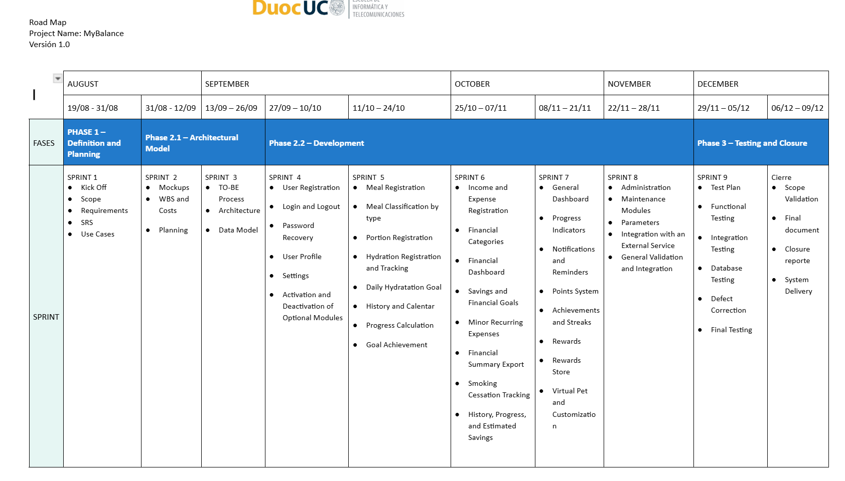

En caso de que el Proyecto APT sea grupal, en esta columna deben indicar el nombre de los responsables de cada tarea o actividad. Esto posteriormente permitirá diferenciar la evaluación por cada integrante.

